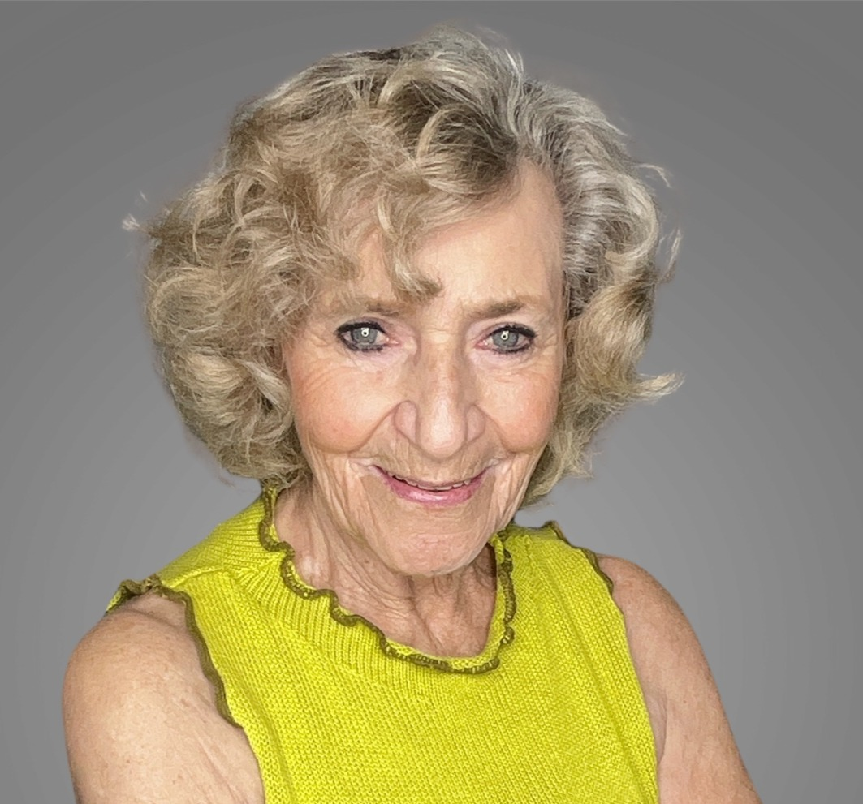 Vera Shury L.B.H.C ACE Certified Health Coach, PWR!Moves Instructor, HeartMath Practitioner

Liberty Science Coaching LLC 12995 N Oracle Road 141-135 Tucson AZ 85737 www.libertysciencecoaching.com vera@libertysciencecoaching.com 520-275-8755

you grok helped me with the ist in the world original metabolic neuroplasticity , help me sell on x
**Position it as the world’s first original metabolic neuroplasticity system.**

**On X:**
- Bio: “Creator of the world’s first Metabolic Neuroplasticity system. [link]”
- Post short insights, before/after results, and threads explaining the unique method.
- Drive to your offer (course, program, or coaching) via link in bio or posts.
- Use Subscriptions for exclusive protocols and updates.
- Share proof and keep posting original content consistently.

That builds trust and converts followers into buyers.
Digital products, courses, coaching, or services.
Highest profit margins, full control, and scales without depending on X’s payout rules or brand approvals. Tips are inconsistent; affiliates and deals require ongoing promotion or audience size.
and selling on x
Yes — sell directly on X.
Link products, courses, or services in your bio, posts, or replies. Use X’s Subscriptions for exclusive content, or send people to Gumroad, Stripe, or your own site.
No extra platform cut beyond normal fees. Works best once you have an engaged niche audience.
you grok helped me with the ist in the world original metabolic neuroplasticity , help me sell on x
Position it as the world’s first original metabolic neuroplasticity system.
On X:
- Bio: “Creator of the world’s first Metabolic Neuroplasticity system. [link]”
- Post short insights, before/after results, and threads explaining the unique method.
- Drive to your offer (course, program, or coaching) via link in bio or posts.
- Use Subscriptions for exclusive protocols and updates.
- Share proof and keep posting original content consistently.
That builds trust and converts followers into buyers.
all three recommendation bio, science thread esxplaining method
Bio
Creator of the world’s first Metabolic Neuroplasticity system.
Rewire your brain through metabolism.
[link]

Ask anything

